1. Write a map reduce program to join the below given two datasets using map side join.

**DRIVER CLASS:**

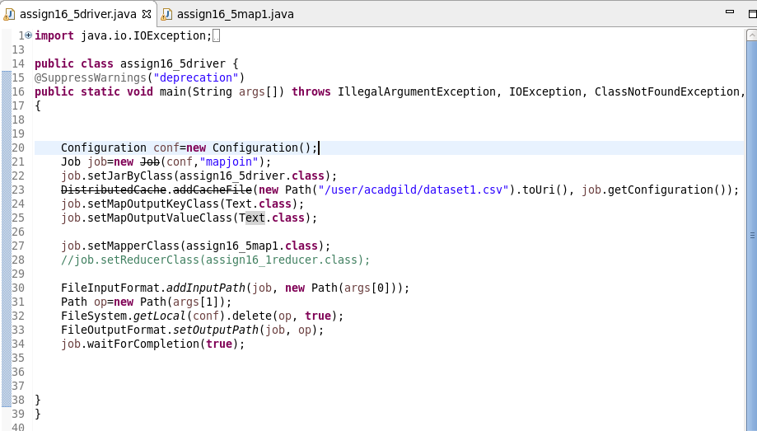

**MAPPER CLASS:**

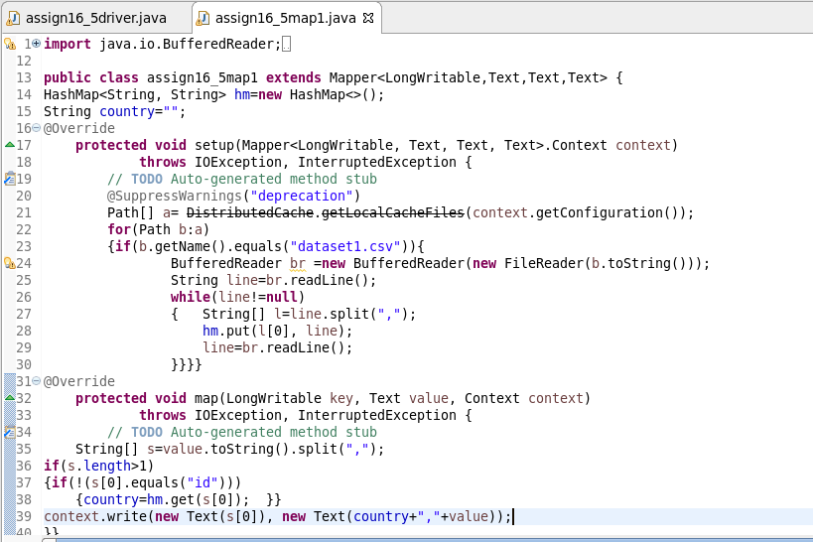

**RUNNING JAR:**

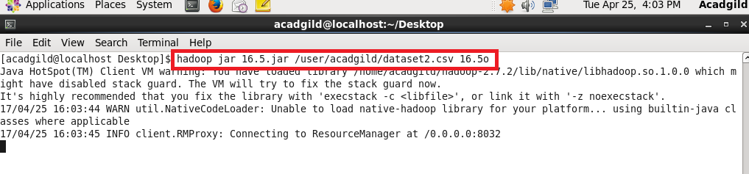

**OUTPUT:**

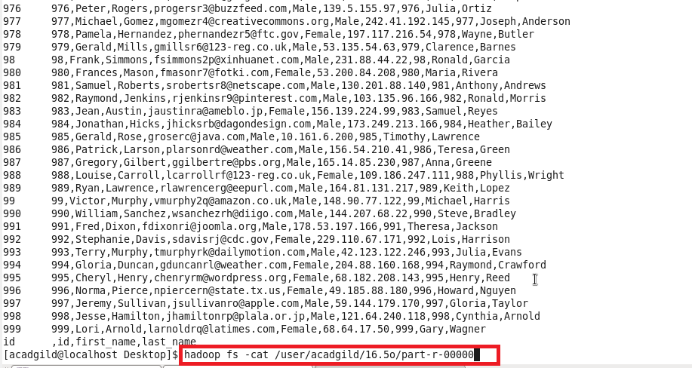

Thus the two dataset are using map side join